

**LENT**

**HOLY WEEK**

**EASTER**

**ST MARY’S WELWYN, ST MICHAEL’S WOOLMER GREEN and AYOT ST PETER**

**2024**

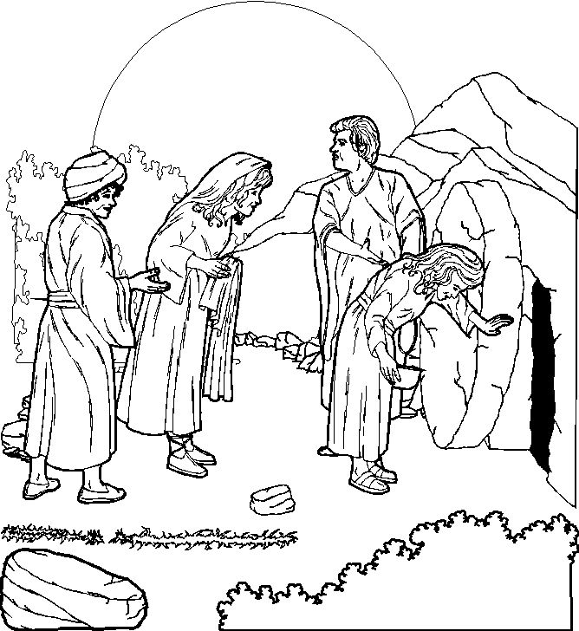

**Rectory evening –** come and enjoy a drinks and panckaes party with friends on Saturday 10th February at 8pm at the Rectory – 2 Ottway Walk. A last chance to indulge before a Lenten fast….

**Shrove Tuesday**



Hopefully you will see the publicity for our Village Pancake Race. This will be on Shrove Tuesday 13th February at 3.45pm outside St Mary’s church, Welwyn, and running along Codicote Road. There will various age categories, and the race will be a relay of four teams of five runners. This year there will be no pre-booking of teams – but all should arrive by 3.35 to register. Teams need one frying pan each, and fancy dress is much encouraged – come along and cheer on the various teams, and make this a really good church and village event.

**Ash Wednesday (February 14th)**

At 9.30 and 8pm there will be a Eucharist with Imposition of Ash at St Mary’s Welwyn. All are welcome and encouraged to make this start to the Lenten season.



There are various ways to keep this theme in Lent on the Church of England Website at - <https://www.churchofengland.org/our-faith/what-we-believe/lent-holy-week-and-easter/livelent-embracing-justice-our-lent-reflections>

This includes daily reflections for adults and children, as well as other resources. You can sign up for them on the website

**Lent course**

**You may not be aware but one of the most important collections of modern religious art in the world is held by the Methodist Church of the UK**. **It so happens that it is being exhibited at the Focolare Centre, AL8 6JG, in Welwyn Garden City over the period of Lent (from March 1st to April 7th).** Our local ecumenical group is producing a Lent group to go accompany the exhibition. This is a unique opportunity to see this collection locally and to reflect on it. All the material will be provided free of charge in both hard copy and electronic form. The groups around the team are listed below – do please feel free to join any of them, or if needed different ones on different weeks. It would be great to see you to study and think together. In addition we will arrange several visits to the exhibition, or you may wish to make your own arrangements to see it.

**Lent Groups 2024**

**(Groups start after Ash Wednesday – there are six weeks in the course)**

**Tuesday 7.30 – St Michael’s Woolmer Green group**

Led and hosted by Christie and Ryan Gilfeather, 01438 561702, 3 London Road, Woolmer Green

**Wednesday 10.30am St Mary’s New Church House,**

Led by David Munchin, 01438 714150

**Wednesday 7.45 for 8pm, 1 Codicote Road, Welwyn,**

Led by Gay and Mike Carpenter 01438 718439

**Thursday 7pm** Datchworth Church hall Led by Jo Sampson, 01438 816005 (beginning with soup and cheese supper)

**Thursday 7pm** at Codicote Parish Centre (next to St Giles Church), led by Catherine Jupp 07811255311.

**Friday 9.30am Time for Reflection Group at St Mary’s New Church House** Contact Mavis Francis 01438 487851 and Marcia Khan

**Friday 12:30pm** 30 Godfries Close,Tewin. Led by Susannah Underwood, 01438 817183 Beginning with soup lunch

**Mothering Sunday is Sunday 10th March this year**

**Concert by Mosaic Choir on Saturday 16th March at St Mary’s Welwyn at 7.30pm**

**Holy Week and Easter Services**

**Palm Sunday – 24th  March**

8.00am St Mary’s, Welwyn - Said Eucharist with distribution of Palms

9.30am St Mary’s, Welwyn - Parish Eucharist

begins at The Plain (end of School Lane) with the blessing of the Palms and procession to St Mary’s. The service will include the reading of the Passion Gospel in dramatic form.

11.15 St Michael’s Woolmer Green – Parish Eucharist

Including procession, blessing of psalms and dramatic reading of Passion Gospel

11.15am St Peter’s, Ayot – Common Worship Parish Eucharist with distribution of Palms

6.30pm Evening Prayer at Welwyn

**Tuesday 26th March**

9pm Compline at St Mary’s Welwyn

**Wednesday 27th March**

9.30**a**m St Mary’s, Welwyn – Eucharist with prayers for healing

8.00pm St Mary’s, Welwyn – Taize Service

**Maundy Thursday 28th March**

11am Chrism Mass at St Albans Cathedral

8.00pm St Mary’s, Welwyn -

Sung Eucharist of the Last Supper with washing of the feet followed by the Watch until midnight

**Good Friday 29th March**

9.30 – St Michael’s Woolmer Green – All Age Stations of the Cross

12.00 – 1.30pm St Mary’s, Welwyn – Good Friday devotions

1.30-3pm Liturgy of the Passion at St Mary’s Welwyn

**Easter Day, Sunday, 31st March,**

Dawn services at Codicote and Datchworth

8.00am St Mary’s, Welwyn – Said Eucharist

9.30am All age Eucharist St Mary’s, Welwyn, plus Easter egg hunt

11.15 St Michael’s Woolmer Green – Easter Service

11.15am St Peter’s, Ayot - BCP Holy Communion

plus Easter Egg hunt

NB No evening service

**NB BST Begins on Easter Day**

**Easter Monday 1st April – Pilgrimage to St Albans Cathedral**

Meet for Breakfast at Welwyn at 8.30am.