The Liturgy of the Feast of Pentecost

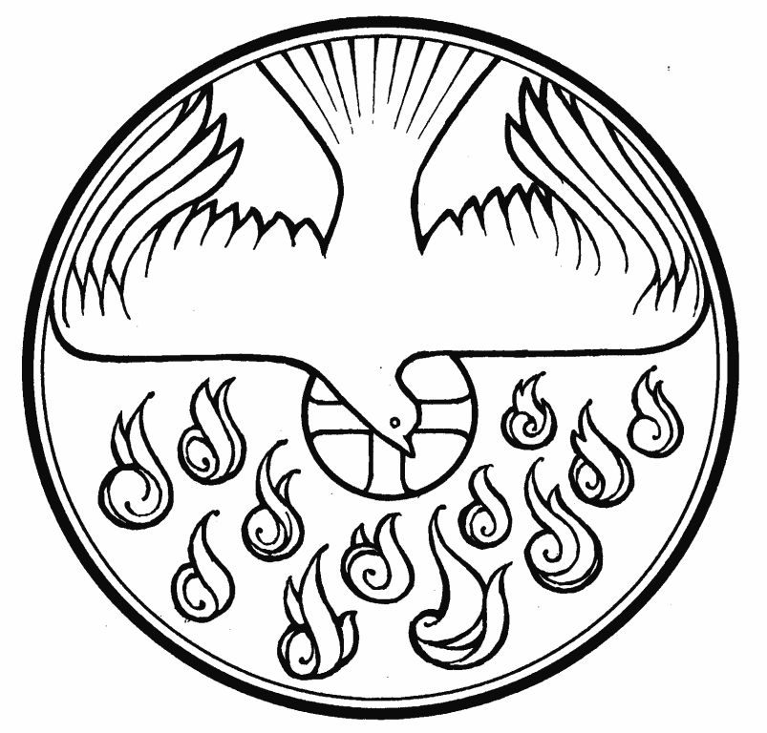

We stand as the ministers enter
The Gathering
In the name of the Father,
and of the Son,
and of the Holy Spirit.
All Amen.

The Greeting
Grace, mercy and peace
from God our Father
and the Lord Jesus Christ be with you.
All And also with you.

Alleluia. Christ is risen.
All He is risen indeed. Alleluia.

Introduction

Jesus Christ, whom we worship, is our crucified, risen and ascended Lord and we have walked with him through his journey of love. We have faced the agony of his suffering and death on a cross. We have rejoiced at his bursting free from the bonds of death. We have enjoyed his risen presence with us
and his revelation of himself through the breaking of bread.
We have seen his return to the throne before which every knee shall bow and every tongue confess that this Jesus is Lord.
And now, with the followers of his own time,
we await the coming of the promised Holy Spirit, his gift to his people, through whom we make Christ known to the world.

We sit

Responsory
As we wait in silence,
All fill us with your Spirit.
As we listen to your word,
All fill us with your Spirit.
As we worship you in majesty,
All fill us with your Spirit.
As we long for your refreshing,
All fill us with your Spirit.
As we long for your renewing,
All fill us with your Spirit.
As we long for your equipping,
All fill us with your Spirit.
As we long for your empowering,
All fill us with your Spirit.

The Choir sing Hymn
- Breathe on me, Breath of God,
Fill me with life anew,
That I may love what Thou dost love,
And do what Thou wouldst do.

- Breathe on me, Breath of God,
Until my heart is pure,
Until with Thee I will one will,
To do and to endure.

- Breathe on me, Breath of God,
Till I am wholly Thine,
Until this earthly part of me
Glows with Thy fire divine.

- Breathe on me, Breath of God,
So shall I never die,
But live with Thee the perfect life
Of Thine eternity.

We stand for The Pentecost Reading

A reading from the Acts of the Apostles (2.1-13)

When the day of Pentecost had come, they were all together in one place. And suddenly from heaven there came a sound like the rush of a violent wind, and it filled the entire house where they were sitting. Divided tongues, as of fire, appeared among them, and a tongue rested on each of them. All of them were filled with the Holy Spirit and began to speak in other languages, as the Spirit gave them ability. Now there were devout Jews from every nation under heaven living in Jerusalem. And at this sound the crowd gathered and was bewildered, because each one heard them speaking in the native language of each. Amazed and astonished, they asked, ‘Are not all these who are speaking Galileans? And how is it that we hear, each of us, in our own native language? Parthians, Medes, Elamites, and residents of Mesopotamia, Judea and Cappadocia, Pontus and Asia, Phrygia and Pamphylia, Egypt and the parts of Libya belonging to Cyrene, and visitors from Rome, both Jews and proselytes, Cretans and Arabs – in our own languages we hear them speaking about God’s deeds of power.’ All were amazed and perplexed, saying to one another, ‘What does this mean?’ But others sneered and said, ‘They are filled with new wine.’ ¹⁴ But Peter, standing with the eleven, raised his voice and addressed them, “Men of Judea and all who live in Jerusalem, let this be known to you, and listen to what I say. ¹⁵ Indeed, these are not drunk, as you suppose, for it is only nine o’clock in the morning. ¹⁶ No, this is what was spoken through the prophet Joel:
¹⁷ ‘In the last days it will be, God declares, that I will pour out my Spirit upon all flesh, and your sons and your daughters shall prophesy, and your young men shall see visions, and your old men shall dream dreams.¹⁸ Even upon my slaves, both men and women, in those days I will pour out my Spirit; and they shall prophesy. ¹⁹ And I will show portents in the heaven above and signs on the earth below, blood, and fire, and smoky mist.
²⁰ The sun shall be turned to darkness and the moon to blood, before the coming of the Lord’s great and glorious day.
²¹ Then everyone who calls on the name of the Lord shall be saved.’

The Lord is here.
All His Spirit is with us.

The Gloria

All Glory to God in the highest,
and peace to his people on earth.
Lord God, heavenly King,
almighty God and Father,
we worship you, we give you thanks,
we praise you for your glory.
Lord Jesus Christ, only Son of the Father,
Lord God, Lamb of God,
you take away the sin of the world:
have mercy on us;
you are seated at the right hand of the Father:
receive our prayer.
For you alone are the Holy One,
you alone are the Lord,
you alone are the Most High, Jesus Christ,
with the Holy Spirit,
in the glory of God the Father.
Amen.
The Collect
Let us pray that the Spirit will work through our lives
to bring Christ to the world.

Silence is kept.

God, who as at this time
taught the hearts of your faithful people
by sending to them the light of your Holy Spirit:
grant us by the same Spirit
to have a right judgement in all things
and evermore to rejoice in his holy comfort;
through the merits of Christ Jesus our Saviour,
who is alive and reigns with you,
in the unity of the Holy Spirit,
one God, now and for ever.
All Amen.

We sit for the Old Testament reading

Ezekiel 37:1-14

The hand of the Lord came upon me, and he brought me out by the spirit of the Lord and set me down in the middle of a valley; it was full of bones. ² He led me all around them; there were very many lying in the valley, and they were very dry. ³ He said to me, “Mortal, can these bones live?” I answered, “O Lord God, you know.” ⁴ Then he said to me, “Prophesy to these bones, and say to them: O dry bones, hear the word of the Lord. ⁵ Thus says the Lord God to these bones: I will cause breath^{[a]} to enter you, and you shall live. ⁶ I will lay sinews on you, and will cause flesh to come upon you, and cover you with skin, and put breath^{[b]} in you, and you shall live; and you shall know that I am the Lord.” ⁷ So I prophesied as I had been commanded; and as I prophesied, suddenly there was a noise, a rattling, and the bones came together, bone to its bone. ⁸ I looked, and there were sinews on them, and flesh had come upon them, and skin had covered them; but there was no breath in them. ⁹ Then he said to me, “Prophesy to the breath, prophesy, mortal, and say to the breath:^{[c]} Thus says the Lord God: Come from the four winds, O breath,^{[d]} and breathe upon these slain, that they may live.” ¹⁰ I prophesied as he commanded me, and the breath came into them, and they lived, and stood on their feet, a vast multitude.
¹¹ Then he said to me, “Mortal, these bones are the whole house of Israel. They say, ‘Our bones are dried up, and our hope is lost; we are cut off completely.’ ¹² Therefore prophesy, and say to them, Thus says the Lord God: I am going to open your graves, and bring you up from your graves, O my people; and I will bring you back to the land of Israel. ¹³ And you shall know that I am the Lord, when I open your graves, and bring you up from your graves, O my people. ¹⁴ I will put my spirit within you, and you shall live, and I will place you on your own soil; then you shall know that I, the Lord, have spoken and will act, says the Lord.”

This is the word of the Lord
Thanks be to God

Gospel Reading

For the acclamation of the gospel the choir sing:
Holy Spirit, Holy Spirit
Come and fill our hearts anew, Holy Spirit.
And we lift our hearts before you as a token of our love,
Holy Spirit, Holy Spirit.

Hear the Gospel of our Lord Jesus Christ according to John.
All Glory to you, O Lord.

²⁶ “When the Advocate^{[a]} comes, whom I will send to you from the Father, the Spirit of truth who comes from the Father, he will testify on my behalf. ²⁷ You also are to testify because you have been with me from the beginning.
“I did not say these things to you from the beginning, because I was with you. ⁵ But now I am going to him who sent me; yet none of you asks me, ‘Where are you going?’ ⁶ But because I have said these things to you, sorrow has filled your hearts. ⁷ Nevertheless I tell you the truth: it is to your advantage that I go away, for if I do not go away, the Advocate^{[a]} will not come to you; but if I go, I will send him to you. ⁸ And when he comes, he will prove the world wrong about^{[b]} sin and righteousness and judgment: ⁹ about sin, because they do not believe in me; ¹⁰ about righteousness, because I am going to the Father and you will see me no longer; ¹¹ about judgment, because the ruler of this world has been condemned.
¹² “I still have many things to say to you, but you cannot bear them now. ¹³ When the Spirit of truth comes, he will guide you into all the truth; for he will not speak on his own, but will speak whatever he hears, and he will declare to you the things that are to come. ¹⁴ He will glorify me, because he will take what is mine and declare it to you. ¹⁵ All that the Father has is mine. For this reason I said that he will take what is mine and declare it to you. John 15:26-27, 16:4b-15

At the end
This is the Gospel of the Lord.
All Praise to you, O Christ.

Sermon by Mick Simmons

The Creed

We believe in one God,
the Father Almighty,
maker of heaven and earth,
of all that is,
seen and unseen.

We believe in one Lord, Jesus Christ,
the only Son of God,
eternally begotten of the Father,
God from God, Light from Light,
true God from true God
begotten not made
of one Being with the Father,
through him all things were made.
For us and for our salvation he came down from heaven,
was incarnate from the Holy Spirit and the Virgin Mary
and was made man.

For our sake he was crucified under Pontius Pilate;
he suffered death and was buried.
On the third day he rose again
in accordance with the Scriptures;
he ascended into heaven
and is seated at the right hand of the Father.
He will come again in glory to judge the living and the dead,
and his kingdom will have no end.

We believe in the Holy Spirit,
the Lord, the giver of life,
who proceeds from the Father and the Son.
who with the Father and the Son is worshipped and glorified,
who has spoken through the prophets.
We believe in one holy catholic and apostolic Church.
We acknowledge one baptism for the forgiveness of sins.
We look for the resurrection of the dead
and the life of the world to come.
Amen.
Prayers of Intercession

The Peace
God has made us one in Christ.
He has set his seal upon us and, as a pledge of what is to come,
has given the Spirit to dwell in our hearts. Alleluia.
cf 2 Corinthians 1.22
The peace of the Lord be always with you
and also with you.

Let us offer one another a sign of peace.
All may exchange a sign of peace.
Preparation of the Table

Blessed be God,
who feeds the hungry,
who raises the poor,
who fills our praise.
All Blessed be God for ever.

The Eucharistic Prayer
The Lord is here
His Spirit is with us

Lift up your hearts
We lift them to the Lord

Let us give thanks to the Lord our God
It is right to give him thanks and praise.
It is indeed right, it is our duty and our joy,
always and everywhere to give you thanks,
holy Father, almighty and everlasting God,
through Jesus Christ, your only Son our Lord.
This day we give you thanks
because in fulfilment of your promise
you pour out your Spirit upon us,
filling us with your gifts, leading us into all truth,
and uniting peoples of many tongues in the confession of one faith.

Your Spirit gives us grace to call you Father,
to proclaim your gospel to all nations
and to serve you as a royal priesthood.
Therefore we join our voices with angels and archangels,
and with all those in whom the Spirit dwells,
to proclaim the glory of your name,
for ever praising you and saying:
Holy, holy, holy Lord
God of power and might,
heaven and earth are full of your glory,
Hosanna in the highest.
Blessed is he who comes in the name of the Lord.
Hosanna in the highest.

Accept our praises, heavenly Father,
through your Son our Saviour Jesus Christ,
and as we follow his example and obey his command,
grant that by the power of your Holy Spirit
these gifts of bread and wine
may be to us his body and his blood;
who in the same night that he was betrayed,
took bread and gave you thanks,
he broke it and gave it to his disciples, saying:
Take, eat; this is my body which is given for you;
do this in remembrance of me.

In the same way after supper
he took the cup and gave you thanks;
he gave it to them saying:
Drink this, all of you; this is my blood of the new covenant,
which is shed for you and for many for the forgiveness of sins.
Do this as often as you drink it, in remembrance of me.

Therefore heavenly Father,
we remember his offering of himself made once for all upon the cross;
we proclaim his mighty resurrection and glorious ascension;
we look for the coming of his kingdom,
and with this bread and this cup
we make the memorial of Christ your Son our Lord.

Great is the mystery of faith:
Christ has died,
Christ is risen,
Christ will come again.

Accept through him, our great high priest,
this our sacrifice of thanks and praise,
and as we eat and drink these holy gifts
in the presence of your divine majesty,
renew us by your Spirit,
inspire us with your love
and unite us in the body of your Son,
Jesus Christ our Lord.

Through him and with him and in him,
in the unity of the Holy Spirit,
with all who stand before you in earth and heaven,
we worship you Father Almighty,
in songs of everlasting praise:

Blessing and honour and glory and power
be yours forever and ever Amen.
The Lord’s Prayer

As our Saviour taught us, so we pray:

Our Father in heaven
hallowed be your name,
your kingdom come,
your will be done,
on earth as in heaven.
Give us today our daily bread.
Forgive us our sins
as we forgive those who sin against us.
Lead us not into temptation
but deliver us from evil.
For the kingdom, the power
and the glory are yours
now and forever. Amen.

Breaking of the bread
We break this bread
to share in the body of Christ.
Though we are many, we are one body,
because we all share in one bread.
Agnus Dei

Lamb of God, you take away the sin of the world,
have mercy on us.
Lamb of God, you take away the sin of the world,
have mercy on us.
Lamb of God, you take away the sin of the world,
grant us peace.

Invitation to Communion

Alleluia. Christ our Passover is sacrificed for us.
Therefore let us keep the feast. Alleluia.

At home you may like to use this Prayer of Spiritual Communion

My Jesus, I believe that You
are present in the Most Holy Sacrament.
I love You above all things,
and I desire to receive You into my soul.
Since I cannot at this moment
receive You sacramentally,
come at least spiritually into my heart. I embrace You as if You were already there and unite myself wholly to You. Never permit me to be separated from You. Amen.

During Communion the Choir will sing:

Hymn
1 Come, Holy Ghost, our souls inspire
and lighten with celestial fire;
thou the anointing Spirit art,
who dost thy sevenfold gifts impart.

2 Thy blessed unction from above
is comfort, life, and fire of love;
enable with perpetual light
the dullness of our mortal sight.

3 Teach us to know the Father, Son,
and thee, of both, to be but one;
that through the ages all along
this may be our endless song:

4 Praise to thine eternal merit,
Father, Son and Holy Spirit.
Amen.

Prayer after Communion
Faithful God,
who fulfilled the promises of Easter
by sending us your Holy Spirit
and opening to every race and nation
the way of life eternal:
open our lips by your Spirit,
that every tongue may tell of your glory;
through Jesus Christ our Lord.
All Amen.
Hymn
The choir sing:

Spirit of mercy, truth and love,
O shed thine influence from above,
and still from age to age convey
the wonders of this sacred day.

In every climate, by every tongue,
be God’s surpassing glory sung;
let all the listening earth be taught
the acts our great Redeemer wrought.

Unfailing comfort. heavenly guide,
still o’er thy holy Church preside;
still let mankind thy blessings prove,
Spirit of mercy, truth and love.

Blessing of Light
Blessed are you, sovereign God, overflowing in love.
With Pentecost dawns the age of the Spirit.
Now the flame of heaven rests on every believer.
Strong and weak, women and men tell out your word;
the young receive visions, the old receive dreams.
With the new wine of the Spirit
they proclaim your reign of love.
Amid the birth pangs of the new creation
the way of light is made known.
Source of freedom, giver of life,
blessed are you, Father, Son and Holy Spirit.
All Blessed be God for ever.

You may like to now light a candle in your own home as a reminder of the gift of the Holy Spirit given to you.

Commission
For fifty days we have celebrated the victory of our Lord Jesus Christ over the powers of sin and death. We have proclaimed God’s mighty acts and we have prayed that the power that was at work when God raised Jesus from the dead might be at work in us.

As part of God’s Church here at St. Peter’s Tewin I call upon you to live out what you proclaim:

Empowered by the Holy Spirit, will you dare to walk into God’s future, trusting him to be your guide?
All By the Spirit’s power, we will.
Will you dare to embrace each other and grow together in love?
All We will.
Will you dare to share your riches in common and minister to each other in need?
All We will.
Will you dare to pray for each other until your hearts beat with the longings of God?
All We will.
Will you dare to carry the light of Christ into the world’s dark places?
All We will.

The Easter Candle is extinguished.
Conclusion

Today we have remembered the coming of God’s power on the disciples and we invite that same Spirit to drive us out into the wild places of the world.

May Christ’s holy, healing, enabling Spirit be with you
and guide you on your way at every change and turn;
and the blessing of God almighty,
the Father, the Son, and the Holy Spirit,
be among you and remain with you always.
All Amen.

Filled with the Spirit’s power,
go in the light and peace of Christ. Alleluia, alleluia.
All Thanks be to God. Alleluia, alleluia.

Common Worship: Times and Seasons, material from which is included here,
is copyright © The Archbishops' Council 2006 and published by Church House Publishing.

